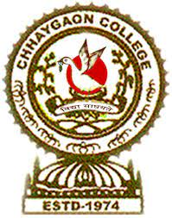

দৰ্শন বিভাগ, ছয়গাওঁ মহাবিদ্যালয়

Department of Philosophy, Chhaygaon College, Chhaygaon, Kamrup (Assam)
No:CC/PHIL-01/2023/ Date: 16.03.2026

NOTICE

This is to inform the students of BA Sixth Semester (Major/Minor), 2026, that an ORAL TEST will be conducted on 28th March at 12 NOON for the paper EXISTENTIALISM in room no 105. It is compulsory for all the students to attempt the test as it is a part of internal assessment.

Head,
Department of Philosophy
Chhaygaon College, Chhaygaon

